Date : 09th March 2021

VOTER AWARENESS PROGRAMME
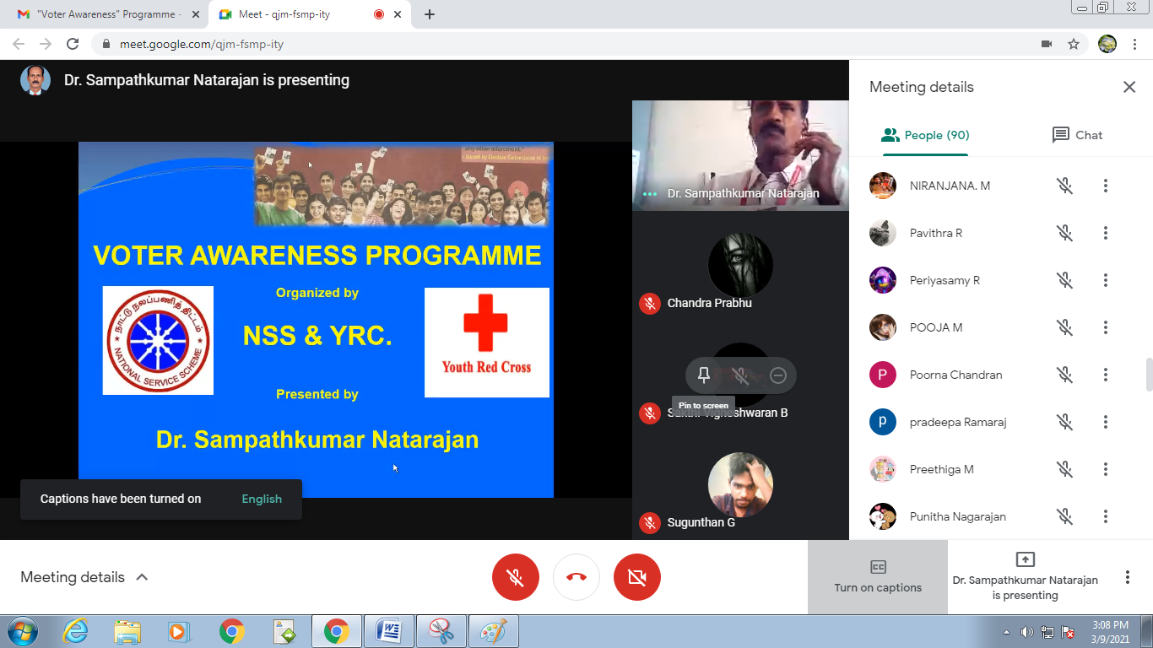
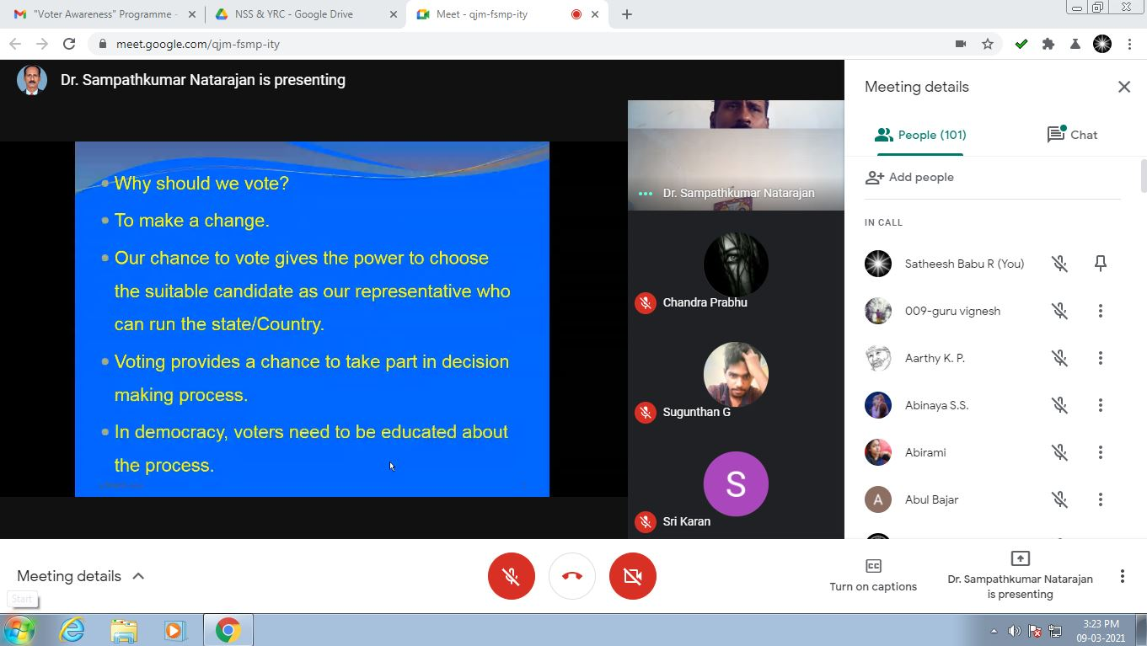
Voter Awareness webinar Programme was held at SSMIET campus on 09.03.2021 successfully.
We were coordinated this Programme with Nehru Yuva Kendra, Dindigul. Totally 98 students and 3 faculty members actively participated under the NSS / SSMIET.

NSS Coordinator Principal
Mr.R.Satheesh Babu

Date : 09th March 2021

VOTER AWARENESS PROGRAMME
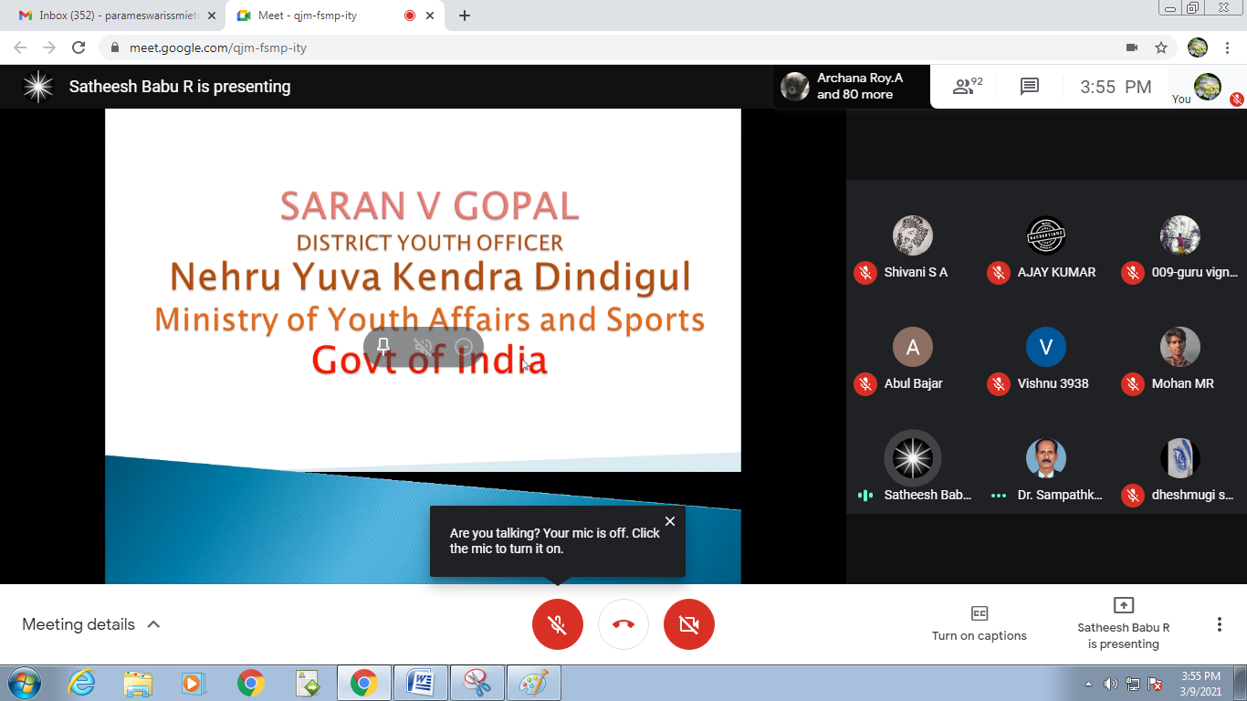
Voter Awareness webinar Programme was held at SSMIET campus on 09.03.2021 successfully.
We were coordinated this Programme with Nehru Yuva Kendra, Dindigul. Totally 89 students and 3 faculty members actively participated under the YRC / SSMIET.

YRC Coordinator Principal
Mrs. A. Parameswari

Voter Awareness Programme - 09.03.2021 (Feedback)
S.No | Name of the Participant(s) | Programme Content | Programme Organization | Clarity of Resource Person's Voice | Explanation by Resource Person | The Whole Programme
1 | ABUL BAJAR S | Excellent | Excellent | Excellent | Excellent | Excellent
2 | BARATH.S | Excellent | Excellent | Very Good | Excellent | Excellent
3 | PREETHIGA M | Excellent | Excellent | Very Good | Excellent | Excellent
4 | ARCHANA ROY A | Very Good | Very Good | Very Good | Excellent | Very Good
5 | SUBHA.S | Excellent | Very Good | Good | Very Good | Very Good
6 | GEETHA MAI A G | Good | Very Good | Good | Good | Very Good
7 | NIRANJANA M | Excellent | Excellent | Excellent | Excellent | Excellent
8 | VIGNESHWAR B | Good | Good | Very Good | Very Good | Very Good
9 | SHARMILA SRINITHI. R | Excellent | Excellent | Excellent | Excellent | Good
10 | SUJITH KUMAR M | Excellent | Excellent | Excellent | Excellent | Excellent
11 | Lakshmi N | Excellent | Excellent | Excellent | Excellent | Excellent
12 | PARTHI PRASATH N | Good | Good | Good | Very Good | Very Good
13 | VIJAY RAGUNATH G.S. | Very Good | Excellent | Very Good | Excellent | Excellent
14 | KISHORE S | Excellent | Excellent | Excellent | Excellent | Excellent
15 | HEMA M | Excellent | Excellent | Good | Excellent | Excellent
16 | M. BHUVANARAJA | Good | Good | Good | Good | Very Good
17 | SAFREEN FATHIMA M | Excellent | Excellent | Excellent | Excellent | Excellent
18 | MOHAMED ABURAR S | Excellent | Excellent | Excellent | Excellent | Excellent
19 | VARUNKUMAR. R | Excellent | Excellent | Very Good | Excellent | Excellent
20 | KAVYAA S M | Good | Very Good | Very Good | Good | Good
21 | DHESHMUGI S | Very Good | Very Good | Very Good | Excellent | Excellent
22 | TAMILSELVAN S | Excellent | Very Good | Excellent | Excellent | Excellent
23 | T. ABIRAMI | Good | Good | Excellent | Excellent | Good
24 | NAGADHARSHINI.G | Excellent | Excellent | Excellent | Excellent | Excellent
25 | SUVETHA R | Excellent | Excellent | Excellent | Excellent | Excellent
26 | JANANI S | Very Good | Good | Very Good | Good | Very Good
27 | Shalini S | Very Good | Very Good | Very Good | Very Good | Very Good

Voter Awareness Programme
09.03.2021 (NSS)
S.No | Name of the Participant(s) | S.No | Name of the Participant(s)
1 | ABUL BAJAR S | 50 | SABITHA M.V
2 | BARATH.S | 51 | SAKTHI PRIYA. P
3 | PREETHIGA M | 52 | HARIHARAN P
4 | ARCHANA ROY A | 53 | SHAMINI.S
5 | SUBHA.S | 54 | ARUN KUMAR G
6 | GEETHA MAI A G | 55 | ISWARYA THANGAPANDIAMMAL.P
7 | NIRANJANA M | 56 | KARUNYA MD
8 | VIGNESHWAR B | 57 | R.PRADEEPA
9 | SHARMILA SRINITHI. R | 58 | MANORANJITHAM G
10 | SUJITH KUMAR M | 59 | PUNITHA VIJAYASRI.P
11 | Lakshmi N | 60 | YOGALAKSHMI B
12 | PARTHI PRASATH N | 61 | MUTHUKUMAR R
13 | VIJAY RAGUNATH G.S. | 62 | SAJIHARINIKA.S
14 | KISHORE S | 63 | HARINI J
15 | HEMA M | 64 | AARTHY K. P.
16 | M. BHUVANARAJA | 65 | SIVASUBRAMANI.S
17 | SAFREEN FATHIMA M | 66 | PERIYASAMY R
18 | MOHAMED ABURAR S | 67 | MUTHUKRISHNAN L M K
19 | VARUNKUMAR. R | 68 | YOGESH V
20 | KAVYAA S M | 69 | RAJAVEMANNA REDDY J
21 | DHESHMUGI S | 70 | AKASH M
22 | TAMILSELVAN S | 71 | KIRUTHIK ROSHINI
23 | T. ABIRAMI | 72 | YOGESH ARASAN A P K
24 | NAGADHARSHINI.G | 73 | LAVANYA RAJENDRAN
25 | SUVETHA R | 74 | MURALI THARAN M
26 | JANANI S | 75 | VIJEY C.R
27 | Shalini S | 76 | MAHAVISHNUVARMAN C
28 | SRI SATHYA NARAYANAN.S | 77 | KRISHNAVENI S
29 | SASIPRIYA S | 78 | UGESH B
30 | VEDHA R | 79 | MANISHA B
31 | AJAY K | 80 | MANIKANDAN G
32 | ARAVINDHAN.M | 81 | EAZHISAI NAMBI S
33 | UMA PRIYADHARSHINI J | 82 | SATHYA M
34 | NIVETHA S | 83 | VASANTH S
35 | MUNIYAPPAN P | 84 | SANMUGAPANDI M
36 | SURIYA SELVAM.I | 85 | ARUL YOWAN P
37 | SAHIL AKTHAR Z | 86 | ARAVIND KUMAR D
38 | ABINAYA S.S. | 87 | BALAJI P M
39 | S.SIVAKUMR | 88 | ASHOKKUMAR M
40 | Vishwa.A | 89 | POORNACHANDRAN P
41 | Muthu kumaran S U | 90 | ARULMURUGAN S
42 | NISHANTHINI S | 91 | STANI QUIETZER B
43 | VARSHINI U | 92 | SHEIK DAWOOD S
44 | SAKTHI VIGNESHWARAN B | 93 | AKALYA A N
45 | PANDIMA DEVI B | 94 | ANU P
46 | SETHU KISHOR R | 95 | AKASH KUMAR M
47 | CHANDRA PRABHU.A | 96 | ARAVINTH S
48 | SUGUNTHAN G | 97 | SIVA SANTHANA BHARATHI M
49 | POOJA M | 98 | ABINAYA T

Voter Awareness Programme
09.03.2021 (YRC)
S.No | Name of the Participant(s) | S.No | Name of the Participant(s)
1 | ABUL BAJAR S | 46 | SETHU KISHOR R
2 | BARATH.S | 47 | CHANDRA PRABHU.A
3 | PREETHIGA M | 48 | SUGUNTHAN G
4 | ARCHANA ROY A | 49 | POOJA M
5 | SUBHA.S | 50 | SABITHA M.V
6 | GEETHA MAI A G | 51 | SAKTHI PRIYA. P
7 | NIRANJANA M | 52 | HARIHARAN P
8 | VIGNESHWAR B | 53 | SHAMINI.S
9 | SHARMILA SRINITHI. R | 54 | ARUN KUMAR G
10 | SUJITH KUMAR M | 55 | ISWARYA THANGAPANDIAMMAL.P
11 | Lakshmi N | 56 | KARUNYA MD
12 | PARTHI PRASATH N | 57 | R.PRADEEPA
13 | VIJAY RAGUNATH G.S. | 58 | MANORANJITHAM G
14 | KISHORE S | 59 | PUNITHA VIJAYASRI.P
15 | HEMA M | 60 | YOGALAKSHMI B
16 | M. BHUVANARAJA | 61 | MUTHUKUMAR R
17 | SAFREEN FATHIMA M | 62 | SAJIHARINIKA.S
18 | MOHAMED ABURAR S | 63 | HARINI J
19 | VARUNKUMAR. R | 64 | AARTHY K. P.
20 | KAVYAA S M | 65 | SIVASUBRAMANI.S
21 | DHESHMUGI S | 66 | PERIYASAMY R
22 | TAMILSELVAN S | 67 | MUTHUKRISHNAN L M K
23 | T. ABIRAMI | 68 | YOGESH V
24 | NAGADHARSHINI.G | 69 | RAJAVEMANNA REDDY J
25 | SUVETHA R | 70 | AKASH M
26 | JANANI S | 71 | KIRUTHIK ROSHINI
27 | Shalini S | 72 | YOGESH ARASAN A P K
28 | SRI SATHYA NARAYANAN.S | 73 | LAVANYA RAJENDRAN
29 | SASIPRIYA S | 74 | MURALI THARAN M
30 | VEDHA R | 75 | VIJEY C.R
31 | AJAY K | 76 | MAHAVISHNUVARMAN C
32 | ARAVINDHAN.M | 77 | KRISHNAVENI S
33 | UMA PRIYADHARSHINI J | 78 | UGESH B
34 | NIVETHA S | 79 | MANISHA B
35 | MUNIYAPPAN P | 80 | MANIKANDAN G
36 | SURIYA SELVAM.I | 81 | EAZHISAI NAMBI S
37 | SAHIL AKTHAR Z | 82 | SATHYA M
38 | ABINAYA S.S. | 83 | VASANTH S
39 | S.SIVAKUMR | 84 | SANMUGAPANDI M
40 | Vishwa.A | 85 | ARUL YOWAN P
41 | Muthu kumaran S U | 86 | ARAVIND KUMAR D
42 | NISHANTHINI S | 87 | BALAJI P M
43 | VARSHINI U | 88 | ASHOKKUMAR M
44 | SAKTHI VIGNESHWARAN B | 89 | POORNACHANDRAN P
45 | PANDIMA DEVI B

